Sales & AMC Entry Form — Frontend API + Field Mapping (FieldDesk)
Scope: UI + API integration + calculation logic only (NO Save/POST, NO Edit/Prefill).

API Base Path: https://fielddesk.in/app/api/ (append filename)
Example: https://fielddesk.in/app/api/getsalesinvno.php

Reference UI Screenshot
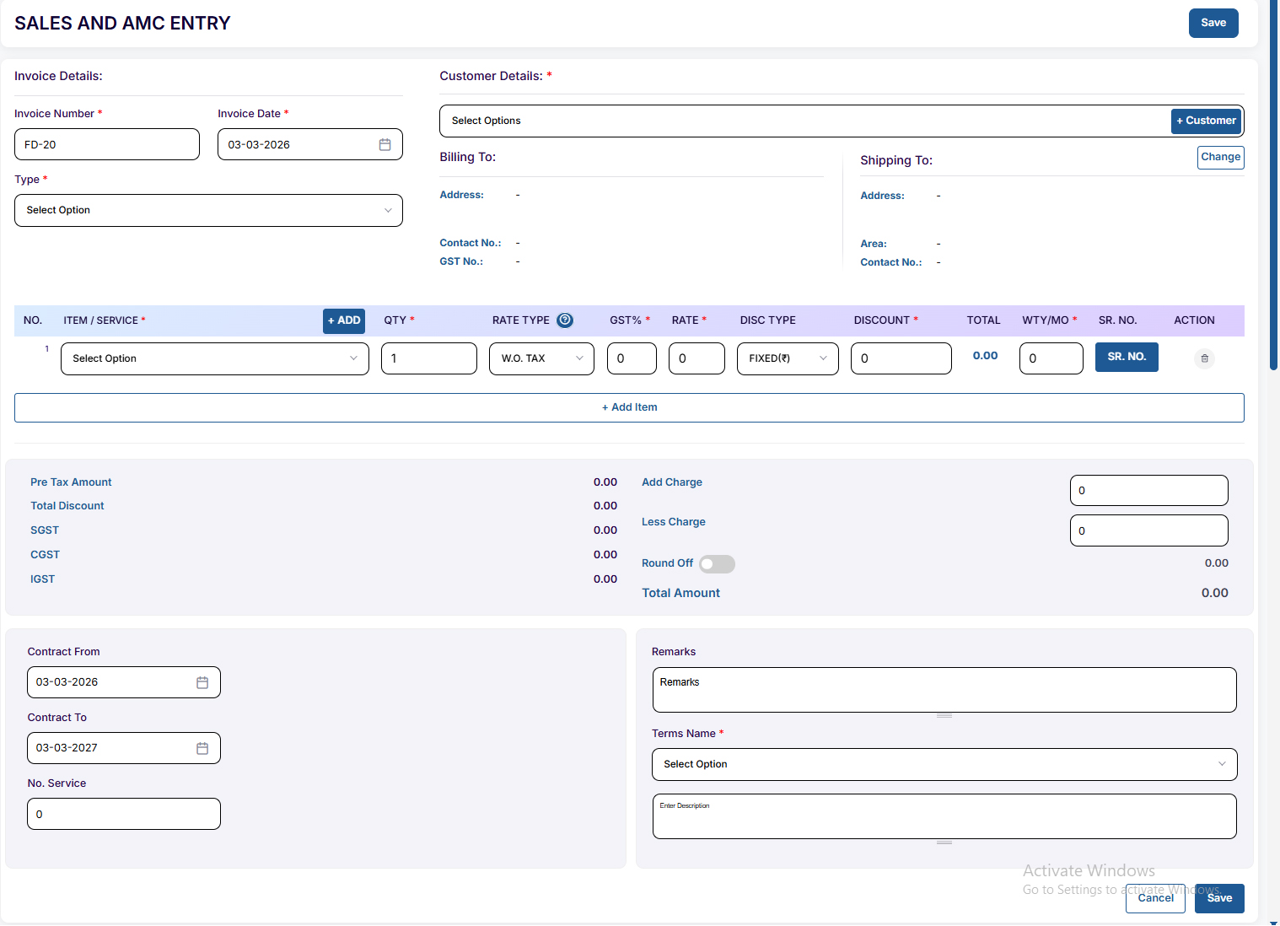
Figure 1: Sales and AMC Entry screen (reference for layout & field positions).

Candidate Deliverables
- Create frontend page matching the provided layout (Sale & AMC Entry).
- Integrate dropdown/search APIs (Customer, Item/Service, AMC Type, Terms).
- Auto-fill billing/shipping details after selecting a customer.
- Auto-fill GST%, Rate, Warranty after selecting an item in a row.
- Implement row-wise amount calculation + summary totals (Pre-tax, Discount, Tax split, Add/Less, Round-off, Total).
- No need to implement: Save button submit (POST sale.php), Edit mode (getsaleid), or any backend changes.

Frontend Flow (High Level)
- On page load → call getsalesinvno.php → set Invoice Number (invoice_prefix-invno)+ Transaction Id (invno)+ Company State(company_state).
- Initialize Customer dropdown (Select2 AJAX) → fetch_customers.php (searchTerm).
- When customer selected → call customer.php?getcustomerid=ID → fill Billing/Shipping hidden fields + on-screen labels.
- Decide Tax mode (SGST+CGST vs IGST) using Company State vs Customer State.
- Initialize Item/Service dropdown for each row (Select2 AJAX) → fetch_allitem.php (searchTerm).
- When item selected in a row → call itemmaster.php?getitemid=ID → auto-fill GST%, Rate, Warranty and recalculate.
- Load Terms dropdown → termsandconditionlist.php → on select set Terms Description (summernote).
- If bill type is AMC → load AMC Type options → amctype.php?amctype.

Key UI Fields (IDs & name attributes)
Candidate should keep these IDs/names consistent because sale.js logic expects them:
Invoice
Field (ID) | name attr | Purpose
#invoiceNumber | name=invno | Invoice Number (auto from getsalesinvno.php) + stores data-state=company_state
#transactionId | name=trans_id | Internal transaction id (auto)
#invoiceDate | name=invdate | Invoice Date
#billType | name=bill_type | Type: SALES / AMC / ...
#installationDate | name=instdate | Visible only when Installation=Yes
#AMCType | name=amctype | Visible only when bill_type=AMC

Customer
Field (ID) | name attr | Purpose
#companyNameSelectDD | name=companyname | Customer dropdown (Select2 AJAX)
#billingAddress | name=address | Hidden billing address
#billingContact | name=contact | Hidden billing contact
#billingGstNumber | name=gst | Hidden billing GST
#billingArea | name=area | Hidden billing area
#billingState | name=state | Hidden billing state
#shippingAddress | name=shipping_address | Hidden shipping address
#shippingArea | name=shipping_area | Hidden shipping area
#shippingContact | name=shipping_contact | Hidden shipping contact

Items Table (Row 1 pattern; rows are dynamic)
Field (ID) | name attr | Purpose
#itemName_1 | name=itemname[] | Item/Service dropdown (Select2 AJAX)
#itemQuantity_1 | name=qty[] | Quantity
#itemRateTypeCheckbox_1 | name=ratetype[] | Rate Type: W. TAX / W.O. TAX
#itemGstPer_1 | name=gst_per[] | GST%
#itemRate_1 | name=rate[] | Rate
#itemDiscTypeDD_1 | name=disc_type[] | Discount type: PERCENTAGE / FIXED
#itemDiscValue_1 | name=disc_value[] | Discount value (hidden storage)
#itemDiscAmount_1 | name=disc_amt[] | Discount amount
#itemTotalInput_1 | name=amount[] | Row total (hidden input)
#itemWarranty_1 | name=wr[] | Warranty months
#itemserialNumber_1 | name=serialno[] | Serial No (hidden input / SR. NO button opens modal)

Summary
Field (ID) | name attr | Purpose
#preTaxAmount | name=grossamt | Pre-tax amount total
#totalDiscount | name=totaldisc | Total discount
#SGST | name=sgst | SGST value
#CGST | name=cgst | CGST value
#IGST | name=igst | IGST value
#addCharge | name=addamt | Additional charge (+)
#lessCharge | name=lessamt | Less charge (-)
#roundOff | name=roundoff | Round-off value
#totalAmount | name=totalamt | Final total

Terms/Remarks
Field (ID) | name attr | Purpose
#remark | name=remark | Remarks (summernote)
#termsAndConditionsDD | name=terms_name | Terms name dropdown
#termsAndConditionsDesc | name=terms_desc | Terms description (summernote)

Kindly ensure that the task is completed as thoroughly as possible within 2 working days.
Best Of Luck
API → UI Mapping (exact endpoints + usage)
All endpoints are under: https://fielddesk.in/app/api/
API filename | Method | Where used | Request params | Response keys used | What to do in UI
getsalesinvno.php | GET | Page load (new entry) | — | invoice_prefix, invno, company_state | Set Invoice Number = invoice_prefix + invno, set trans_id = invno, store company_state in #invoiceNumber[data-state].
fetch_customers.php | GET (Select2 AJAX) | Customer dropdown search (#companyNameSelectDD) | searchTerm=<text> | Array of customers: id, name, contact (and code etc.) | Populate dropdown with label: NAME - CONTACT; selected value = customer_id.
customer.php?getcustomerid={id} | GET | On customer selected | getcustomerid=<customer_id> | data[0]: address, contact, gst, area, state | Fill Billing & Shipping hidden fields + labels. Decide Tax Mode: same state → SGST+CGST, else IGST.
fetch_allitem.php | GET (Select2 AJAX) | Item/Service dropdown search (each row .itemname-dropdown) | searchTerm=<text> | Array of items: id, itemname, partcode | Populate item dropdown.
itemmaster.php?getitemid={id} | GET | On item selected in a row | getitemid=<item_id> | data[0]: gst, sal_rate, warranty | Auto-fill row: qty=1, gst_per=gst, rate=sal_rate, warranty=warranty; reset discount/serial; recalc row+summary.
termsandconditionlist.php | GET | Load Terms dropdown | — | terms[]: name, description | Populate Terms dropdown; on select → set terms description editor.
amctype.php?amctype | GET | When bill_type=AMC | amctype (query flag) | amctype[]: id, name | Populate AMC Type dropdown.

GST / Tax Split Logic
Company State comes from getsalesinvno.php (company_state). Customer State comes from customer.php.
Rule:
- • If Company State == Customer State → show SGST + CGST (Tax/2 + Tax/2), hide IGST.
- • Else → show IGST (full Tax), hide SGST & CGST.

Calculation Rules (Row + Summary)
- Row inputs: Qty, Rate, GST%, Rate Type (W. TAX/W.O. TAX), Discount Type (PERCENTAGE/FIXED), Discount value.
- If Rate Type = W. TAX → Rate includes GST. Extract PreTax and Tax from Rate accordingly.
- If Rate Type = W.O. TAX → PreTax = Qty * Rate; Tax = PreTax * GST%/100.
- Discount: if PERCENTAGE → DiscAmt = PreTax * disc%/100; if FIXED → DiscAmt = given amount.
- Row Total = (PreTax - DiscAmt) + Tax (tax calculated on taxable amount per your current JS behavior).
- Summary: sum all rows → PreTaxAmount, TotalDiscount, TotalTax, TotalAmount; then apply AddCharge, LessCharge, RoundOff.

